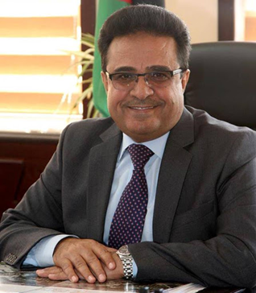

Prof. Saleh Mohammad Rawadieh
Qatar University-College of Education
srawadieh@qu.edu.qa
Prof. Dr. Saleh Mohammad Rawadieh, a Jordanian educator, received a BA in History from Yarmouk University (1987), a Master’s degree from the University of Jordan (1990), and a Ph.D. in Education/ Social Studies from Ohio University in the United States of America (1998). He was promoted to Professor in (2011).
He worked as a professor in a number of Arab universities after obtaining his doctorate: Mutah University (Jordan), Nizwa University (Sultanate of Oman), Al Baha University (Saudi Arabia), the University of Jordan and finally Qatar University. He held many administrative and academic positions in these universities, the last of which was Dean of the Faculty of Educational Sciences at the University of Jordan (2016-2019).
Dr. Rawadieh has authored a number of books in the educational field, and has conducted more than forty research papers, most of which were in the areas of teaching social studies, curriculum analysis, and the uses of technology in the educational process. He also participated in many local, regional and international specialized international seminars and conferences. In addition to his active contributions to the membership of many councils and committees at the national and regional levels, on top of which is participation in the membership of a number of boards of trustees of Jordanian universities.
Dr. Rawadieh also had a large presence in the planning and development of school curriculum in Jordan, especially the social studies curriculum, during the two periods (1990-1994) and (2012-2017).

